UNIVERSITY OF CALIFORNIA, LOS ANGELES
CS M117

CS M117 Student name ___________________DIS:
1A | 1B
Pre-laboratory HW #3. (Due 07/18)
(HW must be typed)
Bluetooth Communications
(Lecture 3)

Section A:
1. (4) Wireless nets:
(a) What is the main similarity between a Wireless LAN and an
Ad Hoc network
(b) What is the main difference?
(a)

(b)

2. (2) Why is multihopping used in Ad-Hoc nets?

3. (1) What is the principal difference between connectionless communication and connection-oriented communication? (See Reading 1).

Section B:
Bluetooth Communications
(T. Ch. 4. 310-317)

1). (4) From Figure 1 shown bellow; we see that a Bluetooth device can be in two piconets at the same time.

M
M
Bridge slave

Figure 1
Is there any reason why one device cannot be the master in both of them
at the same time?

2). (a) (4) Figure 2 shows several physical layer protocols. Which of these is closest to the Bluetooth physical layer protocol?
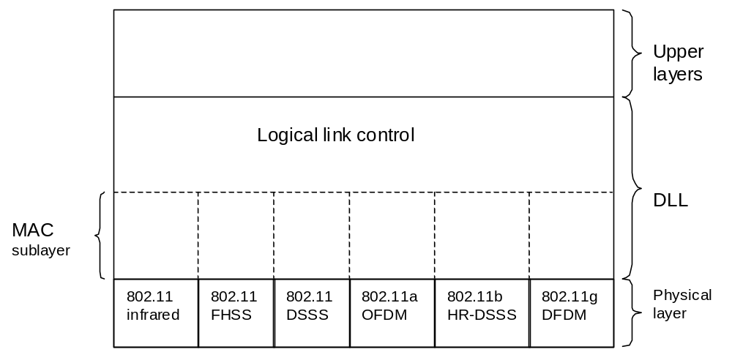
Figure 2

(b) (1). What is the biggest difference between the two?

3). (4) Beacon frame in the frequency hopping spread spectrum variant of 802.11 contain the dwell time, Do you think the analogous beacon frame in Bluetooth also contain the dwell time? Discuss your answer.

